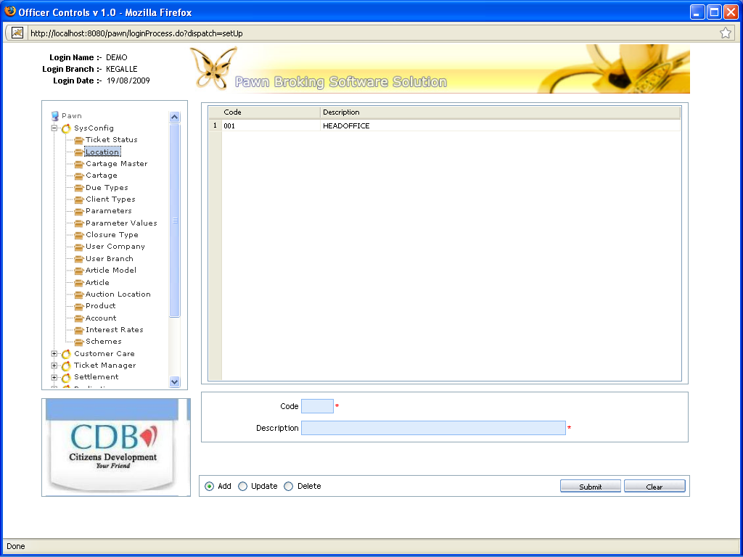

Pawn Broking Software Solution
An automated, versatile and user friendly solution designed to cater to technological needs of the pawn broking financial service industry.

User Manual

Modular4 Solutions (Pvt) Ltd
+94 772 317 666 mahinda@modular4.com

Introduction

Pawn Broking Finances require more features and functionality from a software package than ever before. The Pawn Broking Software Solution pawn broking financial service industry has been developed using the latest in technologies. PBS has recognized the need for a comprehensive series of systems in the market that are reliable, easy to use and relevant to the industry.
The PBS is comprised of a base system and key functional areas that offer a wide number of different Loan and Interest types. PBS is a comprehensive yet user friendly pawn shop computer program available in both single user and multi-user versions. PBS will save your time and money by handling all of these features.
PBS's Pawn management functionality is user-friendly, quick and powerful in both its functionality and reporting.
Summary of Key Features

- Comprehensive Pawn Ticket, Pawn Receipt, Redemption / Settlement and Auction management for your Pawn finance business
- Complete solution to automate the process
- All figures are calculated by the system, cash calculation errors are eliminated
- Full information is kept on every Loan giving you easy access on all enquiries. Information includes Client and Guarantors, as well as financial details, current status, Interest schedule, letters/reminders, transactions, and notes/remarks.
- All information is easily accessed and clearly presented
- Various type of Pawn Receipts (Settlement Receipts, Redemption Receipts, Renewal)
- PBS can produce Overdue Letters for early detection and auctioning of arrears. Letters ranging from mild reminders through to sale of non redeemed can be generated.
- Initial Interest can be calculated on new Loans
- Advanced Search Provision to find the Pawnee quickly
- Customer History and Party summary report will allows u to analyze the party status
- Easily track your pledged item inventory and customer information in one place
- Multiple location allows you to keep the pledged item with ease
- Comprehensive, flexible and user-friendly reports
- Automatic print out of first letters on overdue contracts
- All figures are calculated by the system, cash calculation errors are eliminated
- All contracts can be viewed immediately on screen
- Search for customers by various forms of criteria
- Full range of reports can be printed or viewed on screen
- Password control ensures management security
- Isolate individual pledges to send to auction
- Safe Location Feature
Summary of Key Business Benefits

- Maximize the profit for business and reduce losses
- Reduce Manual work, Increase your free time
- Improved profitability, productivity, efficiency and competitiveness
- Quick decision making
- Find key information fast
- Easily track your customer information in one place.
- Better and more improved customer service levels
- Improved customer satisfaction
- Overall improvement in business reporting and management

